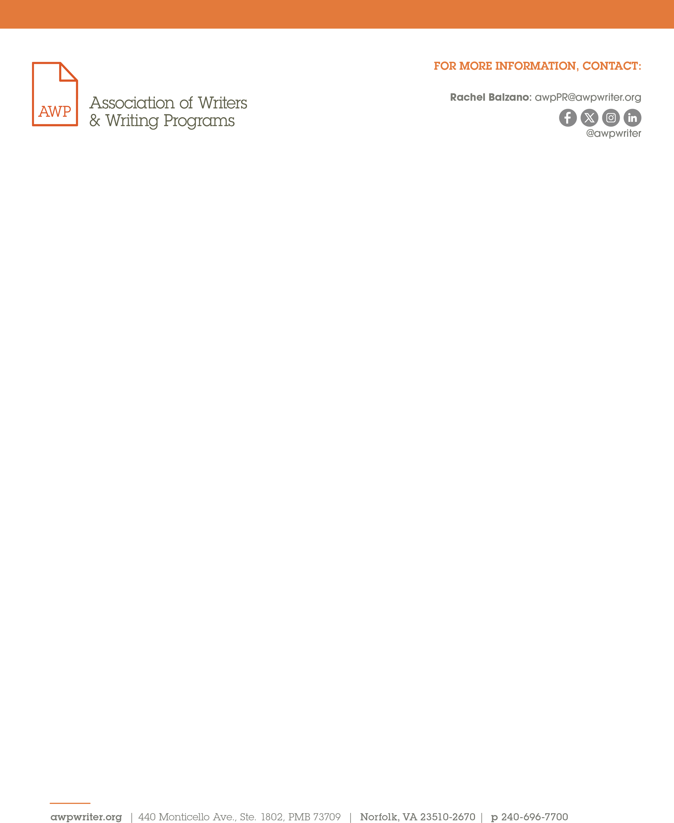
February 12, 2025
FOR IMMEDIATE RELEASE

Announcing the HBCU MFA Think Tank at #AWP25 Participants

Norfolk, VA — The Association of Writers & Writing Programs is excited to announce the twenty funded participants for the HBCU MFA Think Tank. Supported in part by a current generous grant from the National Endowment for the Arts, creative writing educators from historically Black colleges and universities (HBCUs) will convene to explore the viability of MFA programs at HBCUs, where none currently exist. The HBCU MFA Think Thank committee members—Regina Brooks, Kwame Dawes, and A. J. Verdelle—selected fund recipients through an application process.
“I was surprised to discover that none of the more than one hundred HBCUs offer creative writing MFA programs. The HBCU MFA Think Tank will bring together some of the brightest minds to explore establishing advanced literary education programs, so HBCU students can flourish creatively within communities that truly celebrate their voices and experiences,” Regina Brooks said.

Congratulations to these participants:

Khadijah Ali-Coleman, Coppin State University
Kendra Aya, North Carolina A&T State University
Elizabeth Brina, Xavier University of Louisiana
Leiza Brown, Morgan State University
Cynthia Cravens, University of Maryland Eastern Shore
Kelly Norman Ellis, Jackson State University
Latorial Faison, Virginia State University
Hoke Glover, Bowie State University
Piper Huguley, Clark Atlanta University
Tamara Jeffries, South Carolina State University
Danielle Littlefield, Jackson State University
Brande McCleese, Elizabeth City State University
Hannah Saltmarsh, Hampton University
Glenn Shaheen, Prairie View A&M University
Charlene Spearen, Allen University
Shawanda Stewart, Huston-Tillotson University
Charlotte Teague, Alabama A&M University
Jacqueline Trimble, Alabama State University
Tricia Elam Walker, Howard University
Avery Williams, Morehouse College

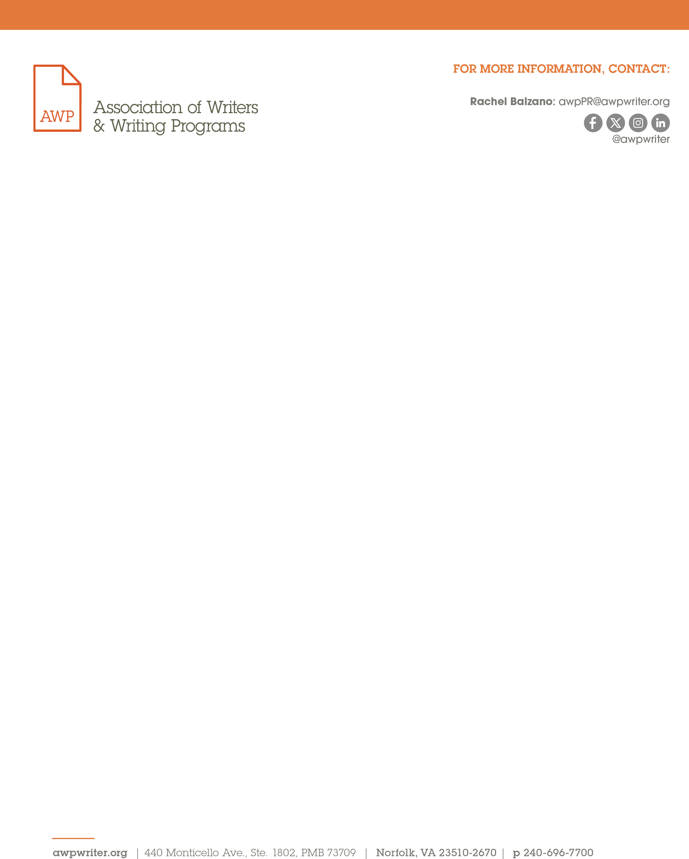

“AWP is honored to host the HBCU MFA Think Tank at #AWP25, a milestone event dedicated to expanding access to MFA programs at HBCUs,” said Michelle Aielli, AWP’s interim executive director. “We extend our gratitude to the HBCU MFA Think Tank committee organizers and the NEA for making this impactful event possible. Advancing MFA programs at HBCUs is a vital initiative fully aligned with AWP’s commitment to fostering opportunities for all writers.”

The annual AWP Conference & Bookfair will be held in Los Angeles on March 26–29, 2025. For more information, please visit our website. For press inquiries, email awpPR@awpwriter.org.
AWP provides support, advocacy, resources, and community to writers, college and university creative writing programs, and writers’ conferences and centers. Our mission is to amplify the voices of writers and the academic programs and organizations that serve them while championing diversity and excellence in creative writing.

